Carousel slide com post php

FUNCTIONS

<?php

//BANNER

function create_post_type(){

register_post_type('banners',

array(

'labels' => array(

'name' => __('Banners'),

'singular_name'=> __('Banners')

),

'supports' => array(

'title', 'editor','thumbnail'

),

'public' => true,

'has_archive' => true,

'menu_icon' => 'dashicons-images-alt2',

'rewrite' => array('slug'=>'banners'),

));

}

add_action('init','create_post_type');

// DEFINIR AS MINIATURAS DOS POSTS

add_theme_support('post-thumbnails');

set_post_thumbnail_size(1280,720,'true');//ajusta a imagem para post em rede sociais |true recorta a imagem

?>

APÓS INSERIR O FUNCTIONS PRECISA APARECER O ICONE BANNERS NO WP-ADMIN

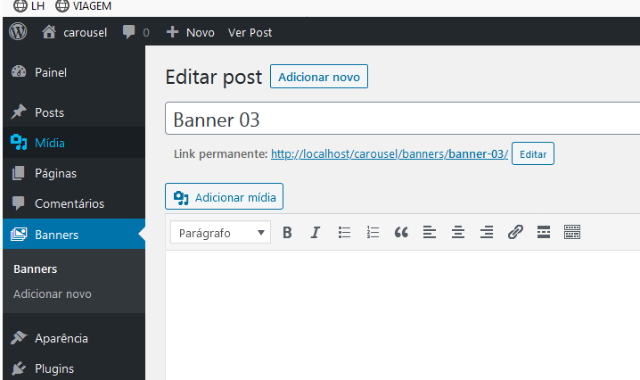

INDEX.PHP

<!DOCTYPE html>

<html lang="en">

<head>

<meta charset="UTF-8">

<title>Document</title>

<link rel="stylesheet" href="<?php bloginfo('template_url'); ?>/css/bootstrap.css">

<link rel="stylesheet" href="<?php bloginfo('template_url'); ?>/style.css">

<link rel="stylesheet" href="<?php bloginfo('stylesheet_url'); ?>">

</head>

<body>

<div class="container">

<div class="row">

<div id="carouselBSWP" class="carousel slide" data-ride="carousel">

<div class="carousel-inner">

<?php

// args

$my_args_banner = array(

'post_type' => 'banners',

'posts_per_page' => 3,

);

// query

$my_query_banner = new WP_Query ( $my_args_banner );

?>

<?php if( $my_query_banner->have_posts()) :

$banner = $banners[0];

$c = 0;

while( $my_query_banner->have_posts() ) :

$my_query_banner->the_post();

?>

<div class="carousel-item <?php $c++; if($c == 1) { echo ' active'; } ?>">

<?php the_post_thumbnail('post-thumbnail', array('class' => 'img-fluid rounded')) ?>

<div class="carousel-caption d-none d-md-block">

<h5>

<?php the_title(); ?>

</h5>

</div>

</div>

<?php endwhile; endif; ?>

<?php wp_reset_query(); ?>

</div>

<a class="carousel-control-prev" href="#carouselBSWP" role="button" data-slide="prev">

<span class="carousel-control-prev-icon"></span>

<span class="sr-only">Anterior</span>

</a>

<a class="carousel-control-next" href="#carouselBSWP" role="button" data-slide="next">

<span class="carousel-control-next-icon"></span>

<span class="sr-only">Próximo</span>

</a>

</div>

</div>

</div>

<script src="<?php bloginfo('template_url') ?>/js/jquery.js"></script>

<script src="<?php bloginfo('template_url') ?>/js/bootstrap.js"></script>

</body>

</html>

<!-- -->